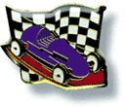
Colt Barker Memorial Derby

Hello All!

We are very excited to invite you to the Colt Barker Memorial Derby Day hosted by Boys Ministry and will be held on April 9, 2022 at the Appalachian Conference campgrounds gym in Dublin, VA. Everyone is welcome; it’s an exciting time for kids and adults of all ages! This will be a great time exploring one of Boys Ministry’s favorite event.

Check-In, pit time, and weigh-in will be from 8:00 – 9:30 am. Racing will begin at 10:00 am.
The fee is $10.00 registration for each participant for the first car. There will be a fee of $2.00 for a second car.

Registration forms are attached. Please have them filled out before you arrive so that you can shorten the line!

We will race five divisions for the boys who have built a new car: Pre-K, K-2nd grade, 3rd-5th grade, 6th-8th grade, and 9th-12th grade. We will have a division for the Girls, Adults (new cars only) and an Open Division which will include anyone with an additional car new or old. As always there will be a Best-of-Show award. And we are happy to be able to include the Modified Division (open to all racers). Refer to the accompanying documents for guidelines regarding requirements/rules for the cars.

Supplies can be ordered through:

Life Spring Recourses: 1-800-541-1376 Item Number 4710040
Healthy Church online store: http://royalrangers.com/gear/rangerderby/kits/
*** For this year’s race kits purchased from Hobby Lobby, Lowes, Michaels Craft Store or ***
anywhere kits are sold will be allowed to race

Each racer will receive a patch.
Food and refreshments may be available for sale, as a fund-raiser for the group providing refreshments.

Once again, we are going to raise money for missions by having an offering. Jesus gave us The Great Commission, so we need to do our part! Please come join us for this fun-filled day! If there are any questions, please call us!
Sincerely,
Freddie Sweet
Appalachian Conference Commander
IPHC Boys Ministry/Royal Rangers
(276) 233-8983
applaconfbmrr@gmail.com
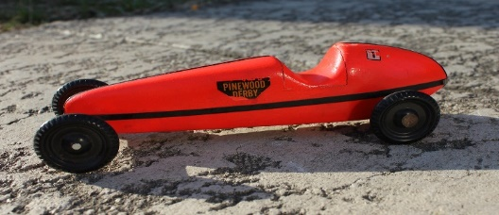
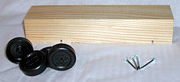
This Photo by Unknown Author is licensed under CC BY

From this to this.
You can do it.

General Rules and Car Specifications
A. The following are guidelines and specifications for the Colt Barker Memorial Derby.
- A contestant may enter only one car per racing class except for Open which is unlimited.

- In order to be eligible for competition (either racing or workmanship), a car must fit on and roll down the track without interfering with any other car.

- Cars must meet the following specifications. Note: Check the kit block before you start. Some variation may exceed the maximums right out of the box.

  - Maximum Length (including all attachments) 7 1/2"
  - Maximum Width 2 3/4"
  - Maximum Height 3"
  - Maximum Weight 5 1/2 oz. (156 grams)
  - Maximum Under-Car Clearance 3/8"

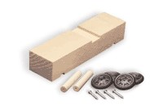
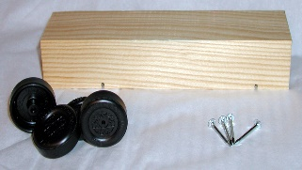
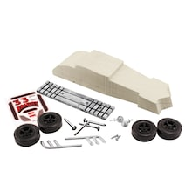
- Pinewood Derby cars will be made from kits sold by Life Spring Resources item no. 4710040 or Healthy Church, item no. 187540. The contestant must use the parts provided in the kit for their intended use. **Because of a recent change in car kits at these providers, we will allow any car kit to participate as long as they meet the rest of the requirements listed. **
This Photo by Unknown Author is licensed under CC BY-SA

5 .The contestant may add weights to the car in order to bring the car to the maximum allowed weight. Weights must be an integral part of the car. They may be placed inside the block, mounted as an ornament, or be otherwise permanently attached. Weights may not be taped or set on a car. If weights or any other part of a car comes off during a heat, the heat will be rerun. If the same car or parts leave the track again, the car is disqualified from racing. No heat/race will be delayed while repairs are made.

- Dry graphite lubricants only.

- Wheels may not be altered in shape or thickness. No metal-to-metal contact is allowed. No washers allowed.

- If a car needs to be lubricated or worked on before it is registered, there will be a designated place setup for that purpose. No work or lubrication can be done after the car has been registered.

- Cars raced at events/races other than local church for practice before this race can only race in open class.

Modified Division Rules

- The modified car can be powered by gravity, electric, air or mechanical means. Car must be free of wire connection once gate is open. Radio controls may be used.

- Car must have a similar axle design and width of kit sold by Life Springs or Healthy Church. No lubricants that remain wet on race day and can drip onto track are allowed. Wheel washers are not allowed.

- Car must fit within the size limit to fit on track.
  - Maximum Length (including all attachments) 7 3/4”
  - Maximum Width 3 1/2 “
  - Maximum Height 4 “
  - Maximum Weight 11 oz. (312 grams)
  - Maximum Under-Car Clearance 3/8"

- Race will consist of three cars or less at a time, as to allow an empty lane to provide room for oversized cars. The number of times each car will race will be determined on race day based on number of participates in class. You may want to make sure your car can race more than one time.

- Car cannot be worked on other than changing or charging battery, changing CO2, turning on or off motors. If damage occurs a review by race officials and limited repair may be allowed. No lubrication or unapproved work will be allowed once car is checked in.

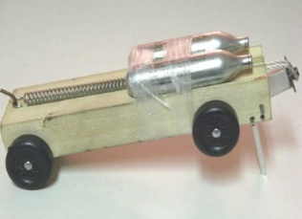
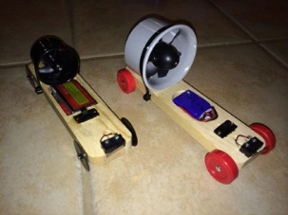
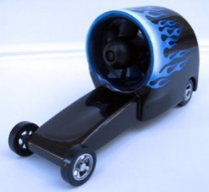
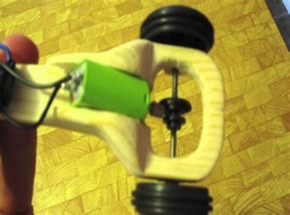
Here are a few examples, find more online.

***No use of incendiary device (fireworks, bottle rockets, flares,etc). No use of liquid propellants or chemical reactions. No use of firearm ammunition. ***

Please fill out before coming to Registration table Car # (Assigned): ____________

First Name:____________________________ Last Name:_______________________________
Church Name or Outpost #: ____________________________________ Affiliation (circle one): IPHC AG
Group (circle one):
Pre-K (Rainbows) K-2nd (Ranger Kids) 3rd-5th (Discovery) 6th-8th (Adventure) 9th-12th (Expedition)

Girls Open Adults (New car) Open (Old car) Modified

Please fill out before coming to Registration table Car # (Assigned): ____________

First Name:____________________________ Last Name:_______________________________
Church Name or Outpost #: ____________________________________ Affiliation (circle one): IPHC AG
Group (circle one):
Pre-K (Rainbows) K-2nd (Ranger Kids) 3rd-5th (Discovery) 6th-8th (Adventure) 9th-12th (Expedition)

Girls Open Adults (New car) Open (Old car) Modified

Please fill out before coming to Registration table Car # (Assigned): ____________

First Name:____________________________ Last Name:_______________________________
Church Name or Outpost #: ____________________________________ Affiliation (circle one): IPHC AG
Group (circle one):
Pre-K (Rainbows) K-2nd (Ranger Kids) 3rd-5th (Discovery) 6th-8th (Adventure) 9th-12th (Expedition)

Girls Open Adults (New car) Open (Old car) Modified

