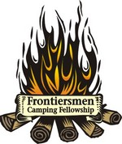 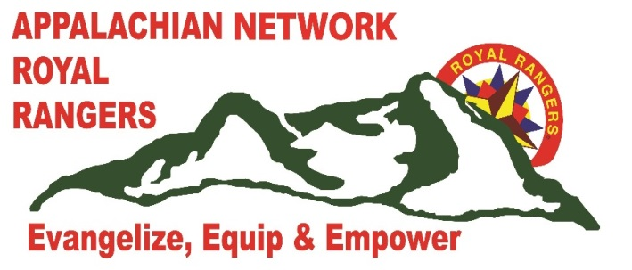 KANAWHA CHAPTER FCF Established 1977
2017 Kanawha Spring Trace Report
6/10/1817

Thank you to all who attended this year’s Spring Trace. We had a great time and a huge village, 7 shelters were erected. It was an awesome site.

We absolutely missed everyone who was not there – our spiritual thumb and fingers were missing. Pastor John Jordan came and delivered powerful messages to us each night at the council fire. What a blessing to have such a man of God, come and deliver God’s word as if he was in an over-packed coliseum. We were richly blessed and forever indebted to Pastor John. It was so exciting for me personally to be able to spend time fellowshipping with Pastor John. He was the first Gold Medal of Achievement winner that I was allowed to mentor in Royal Rangers. I have known John since he was 9 years old. For those who may not be aware Pastor John is fighting a health battle and needs our prayer support. If you are not praying for him and his family daily – please as a favor to me – add him to your prayer time. I can never thank you enough Pastor John for blessing us.

An FCF Business meeting was held. I was honored to introduce our out-going Scout as our new
FCF Vice President. Nathan “No Name” Mullins has agreed to serve our Chapter in that capacity. Please extend congratulations to Nathan the next time you see him. Our newly elected Chapter Scout is Alex “Sitting Ram” whitaker. Alex previously was serving as our Assistant Scout. Welcome back in a new position Alex. We elected a new Assistant Scout – but at this time I have not yet confirmed with him that he will accept the position (stay tuned).

Rick “Simon Tanner” Dostal a National FCF Field Advisor attended our Spring Trace again, (he is becoming a fixture for our Chapter) what a blessing as he always brings excitement with him. He had asked if he could attend and bring his newly forming outpost boys and leaders to give them an introduction to FCF. Thank you Simon for joining us and bringing your men and boys.

Competition – we were so engulfed in fellowship we almost forgot about competition. We only had a Hawk competition this Trace but is was a good one. Our boys took the non-members under their wings and taught them all they knew about throwing a Hawk – unfortunately the students learned better than the teachers. But we all had fun.

Next up for our Chapter is the Network Pow-wow to be held in August. I am depending on our Chapter as I have been assigned to put together the competitions and an FCF village with demos. I need your help! The demos will be in the village and they will only be going on during free time. If you have a shelter please plan on erecting it in our village. Check with me or Nathan about how you can help. This years Pow-wow is a Frontier Theme. Bring your outfit and where it as much as you can stand during the Pow-wow, especially plan on wearing it to council fires. On another note – IF I receive any applications for the Adventure, we will be holding one Friday night and Saturday at the Pow-wow. AS of right now I do not have any applications. If you know someone who wants to go through the Adventure – have them send me an application ASAP.

In October the Territorial Rendezvous will be held in PA. Our chapter is in charge of the Hawk Competition. I am sure I will need some help with that, but for those who are a first time Territorial attendee please make sure you take time to experience the ambiance of the event. My first Territorial was a turning point in my Ranger career (some time if you ask I might share that with you). “Patches” has indicated he is having and Adventure, Buckskin advancement and Wilderness Vigil at the Territorial. If you are wanting / needing to attend one of these events please get that information from the website: https://northeastregionroyalrangers.formstack.com/forms/2017colonialsrendezvous

Welcome to Cody “Smiling Fox” Cox our newest Chapter Member. We are not growing fast but we are growing.

See ya at Pow-wow,
Golden Vulture

